Lab - Setup Prometheus and Grafana using Docker Compose
In this hands-on lab, you’ll deploy Prometheus and Grafana using Docker Compose, configure Prometheus to collect metrics, and connect Grafana to visualize those metrics on dashboards.

Prometheus will scrape data from your servers or applications, and Grafana will turn that data into meaningful dashboards.
Learning Objectives
- Deploy Prometheus and Grafana with Docker Compose.
- Configure Prometheus to collect metrics from a server or application.
- Add Prometheus as a data source in Grafana.
- Create a basic Grafana dashboard to visualize the collected metrics.

Pre-Requisites -
- A Virtual Machine with docker and docker compose installed
- Enable port 3000 (for grafana) and 9090 (for prometheus)

Steps to follow -

Setup Prometheus and Grafana
- Connect to the virtual machine via ssh
- Clone the code from this code repository - Setup Prometheus and Grafana
- Switch to the code directory
- Create two folders - prometheus_data/ and grafana_data/
- Update the permissions of both the directories to allow prometheus and grafana users

sudo chown -R 65534:65534 prometheus_data
sudo chmod -R 775 prometheus_data
sudo chown -R 472:472 grafana_data
sudo chmod -R 775 grafana_data

- Execute the following commands to install prometheus and grafana

docker compose up -d

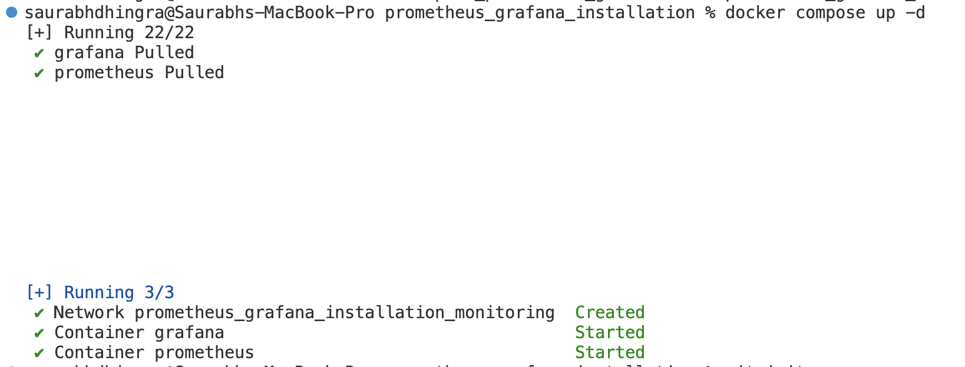

Access the Grafana by navigating to the below url in the browser

http://<public_ip_address>:3000

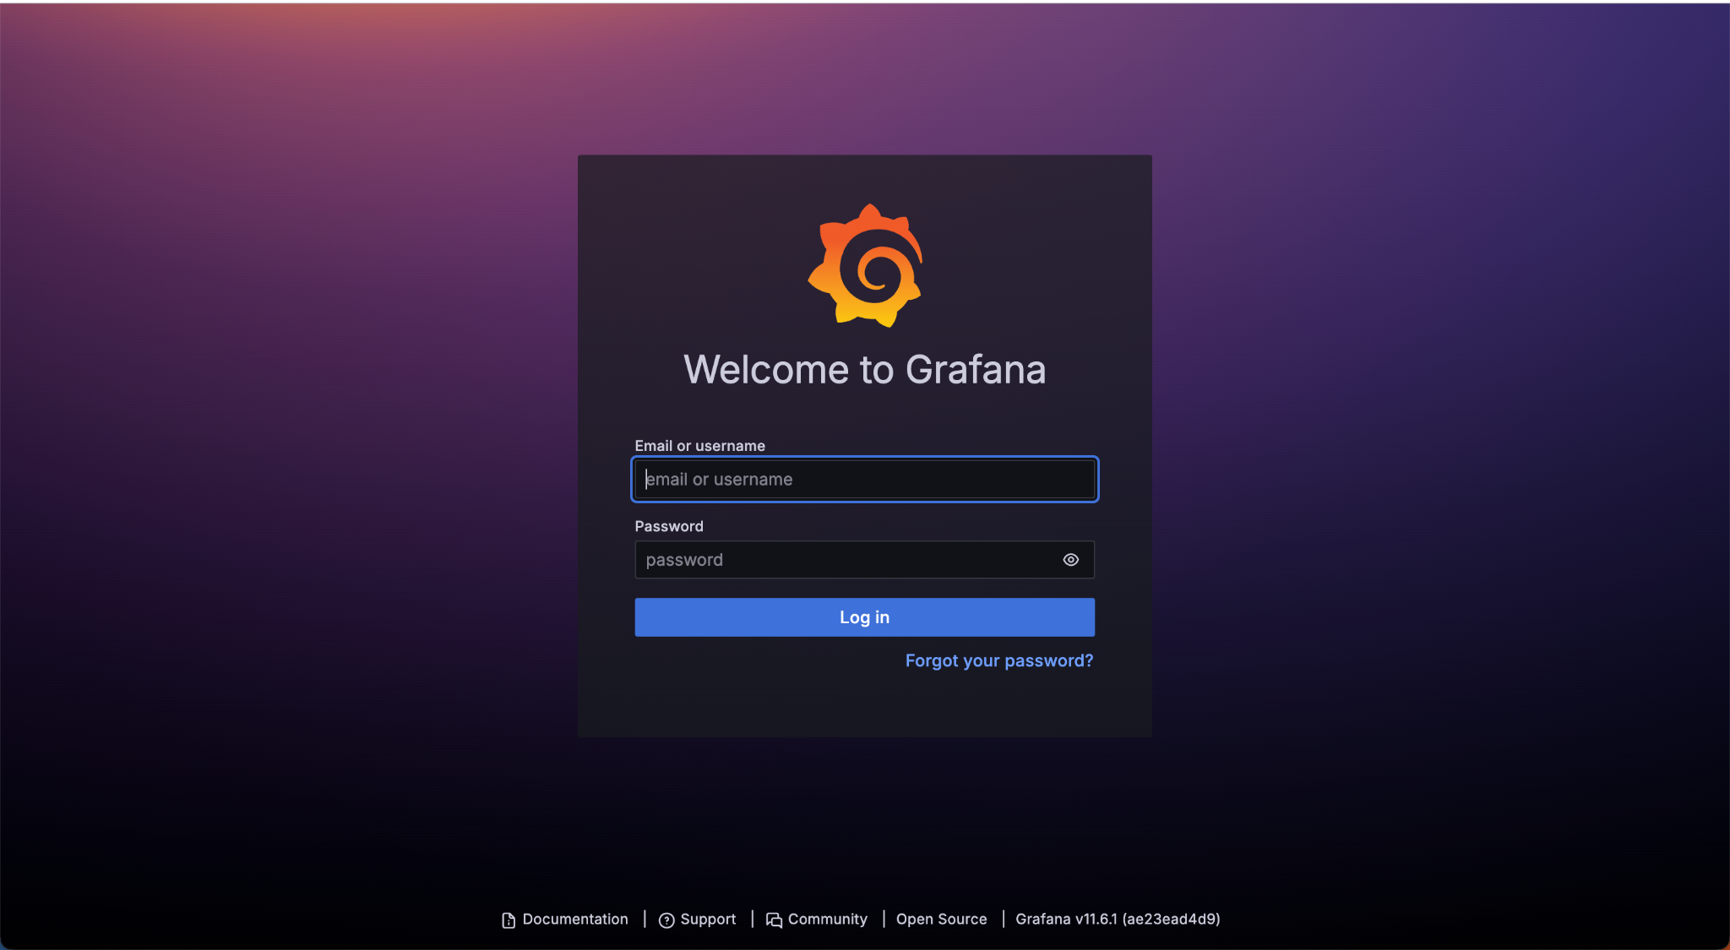

Navigate to the below url in the browser to access Prometheus

http://<public_ip_address>:9090

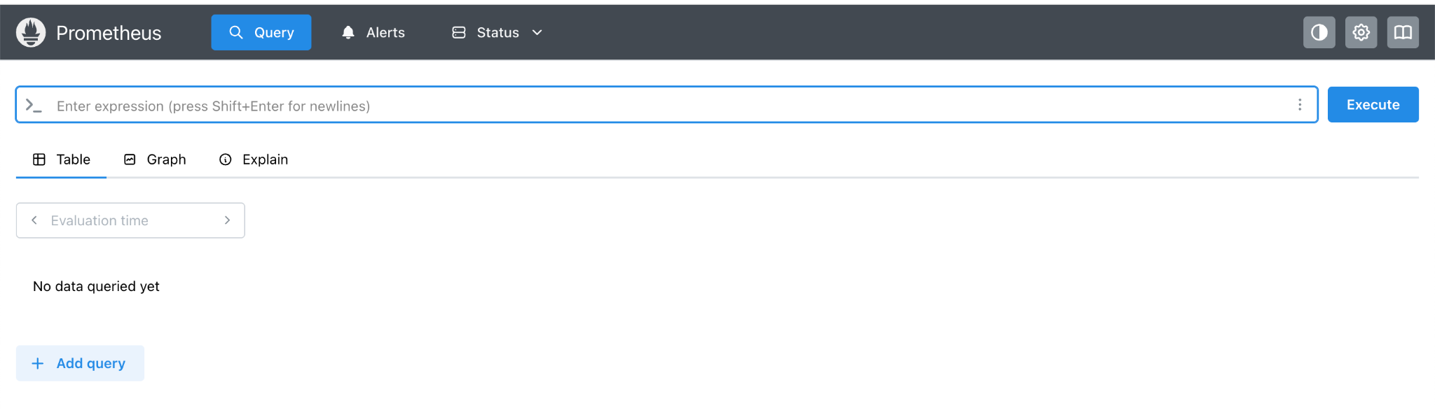

Code Explanation
Let us understand the files used in setting up Prometheus and Grafana.

In the code repository there are two files -

- docker-compose.yml (Definition to deploy both the grafana and prometheus)
- prometheus.yml (Configuration file for prometheus)

docker-compose.yml

Let us understand the docker compose file.

The first section is to create a Prometheus Service.

prometheus:
image: prom/prometheus:latest
container_name: prometheus
restart: unless-stopped
ports:
- "9090:9090"
volumes:
- ./prometheus.yml:/etc/prometheus/prometheus.yml
- ./prometheus_data:/prometheus
networks:
- monitoring

image: Download the latest Prometheus image.
container_name: Give the container a friendly name: prometheus.
restart: Restart automatically if the VM restarts or container crashes.
ports: Map your VM's port 9090 to container’s 9090 (so you can access Prometheus via browser).
volumes:
- First volume mounts your local prometheus.yml inside the container (this tells Prometheus how to scrape metrics).
- Second volume saves Prometheus data (metrics) permanently on your VM (prometheus_data folder).
Second section is to create a Grafana service -
grafana:
image: grafana/grafana:latest
container_name: grafana
restart: unless-stopped
ports:
- "3000:3000"
volumes:
- ./grafana_data:/var/lib/grafana
environment:
- GF_SECURITY_ADMIN_USER=admin
- GF_SECURITY_ADMIN_PASSWORD=admin123
networks:
- monitoring

image: Download the latest Grafana image.
container_name: Name it grafana.
restart: Same auto-restart behavior.
ports: Map your VM's 3000 port to Grafana container’s 3000 port (browser access).
volumes: Save Grafana settings and dashboards permanently to grafana_data.
environment: Set Grafana's login user and password (admin/admin123).
networks: Same network as Prometheus (monitoring) so they can talk easily.
Next section is the Networking
networks:
monitoring:
driver: bridge

Create a bridge network named monitoring.
Both Prometheus and Grafana will share this network to communicate.
Another file we have is prometheus.yml. Let us understand this file.
global:
scrape_interval: 15s
global: Settings that apply everywhere.
scrape_interval: Prometheus will collect data every 15 seconds from its targets.
scrape_configs:
- job_name: 'prometheus'
static_configs:
- targets: ['localhost:9090']
job_name: Give this monitoring job a name: "prometheus".
static_configs: A list of servers to monitor.
- Here we tell Prometheus to scrape itself (because it also exposes metrics).
- localhost:9090 — means it will scrape from its own container's Prometheus server on port 9090.

Add Prometheus as data source in the Grafana
Login to Grafana using the credentials admin and admin123
Note - These are the credentials we set in the docker-compose.yml file.
Next, navigate to the connections >> Add New Connection
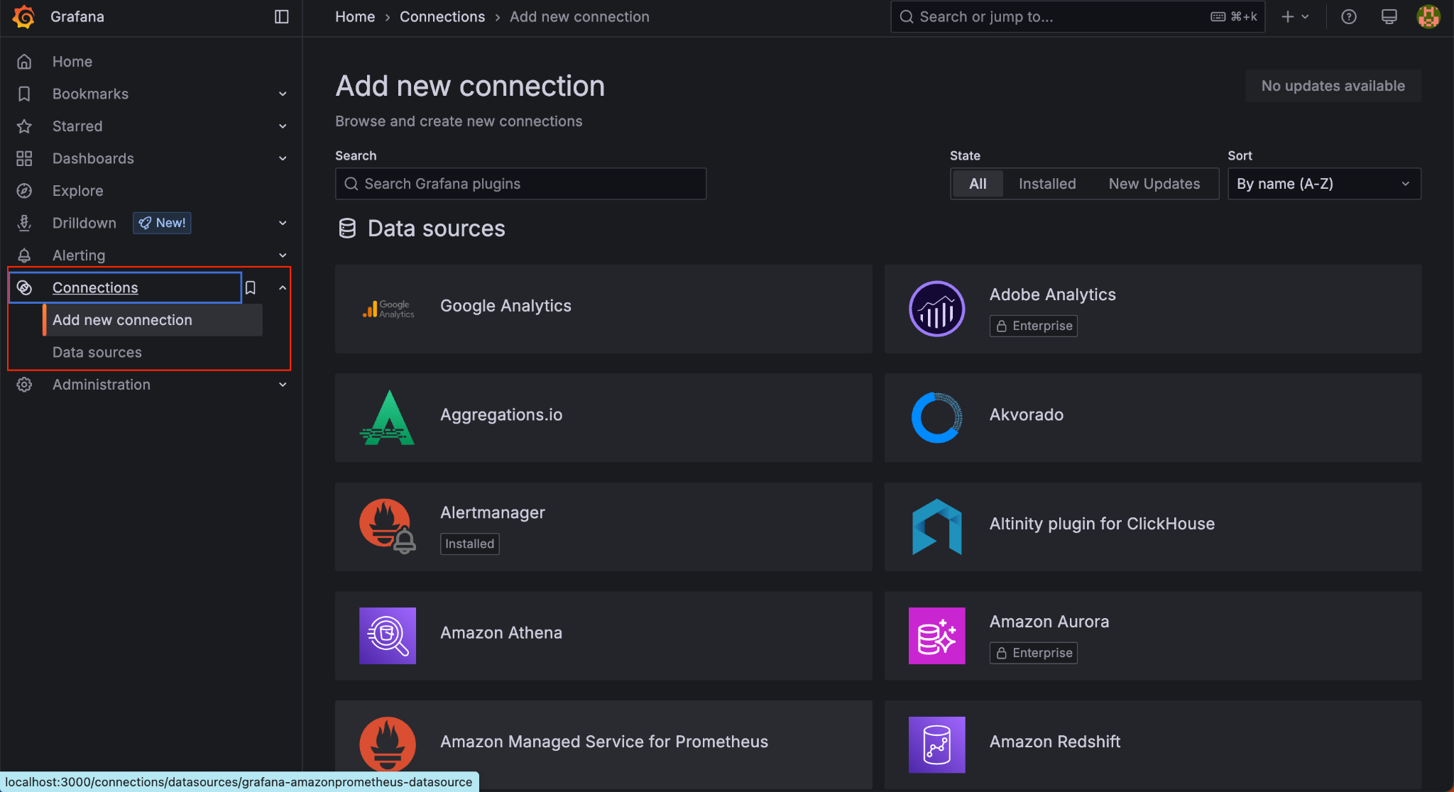
Search for Prometheus in the search bar and select Prometheus
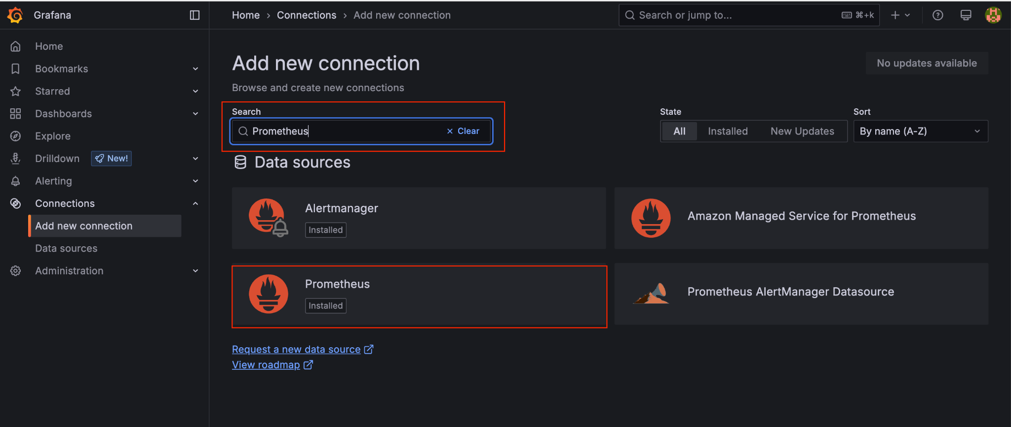
Click on Add new data source.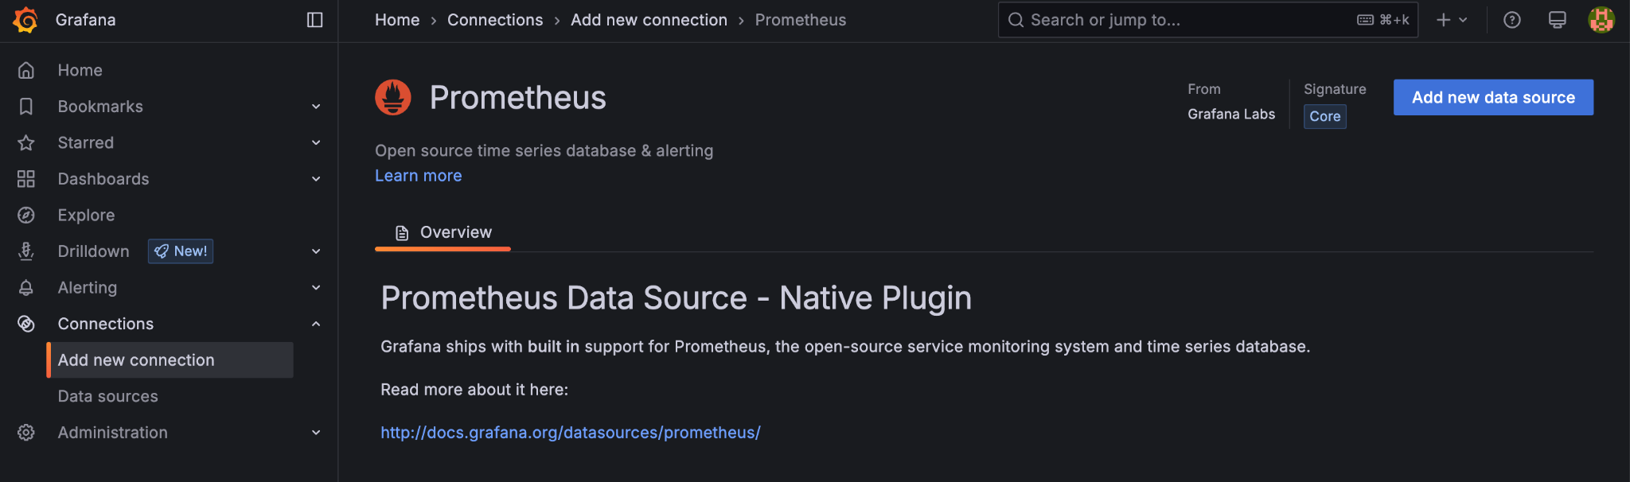
Enter the name of the prometheus as follow -
http://prometheus:9090
Why the service name? Since both the prometheus and grafana are running with the same network (check docker compose). It is discoverable through name.
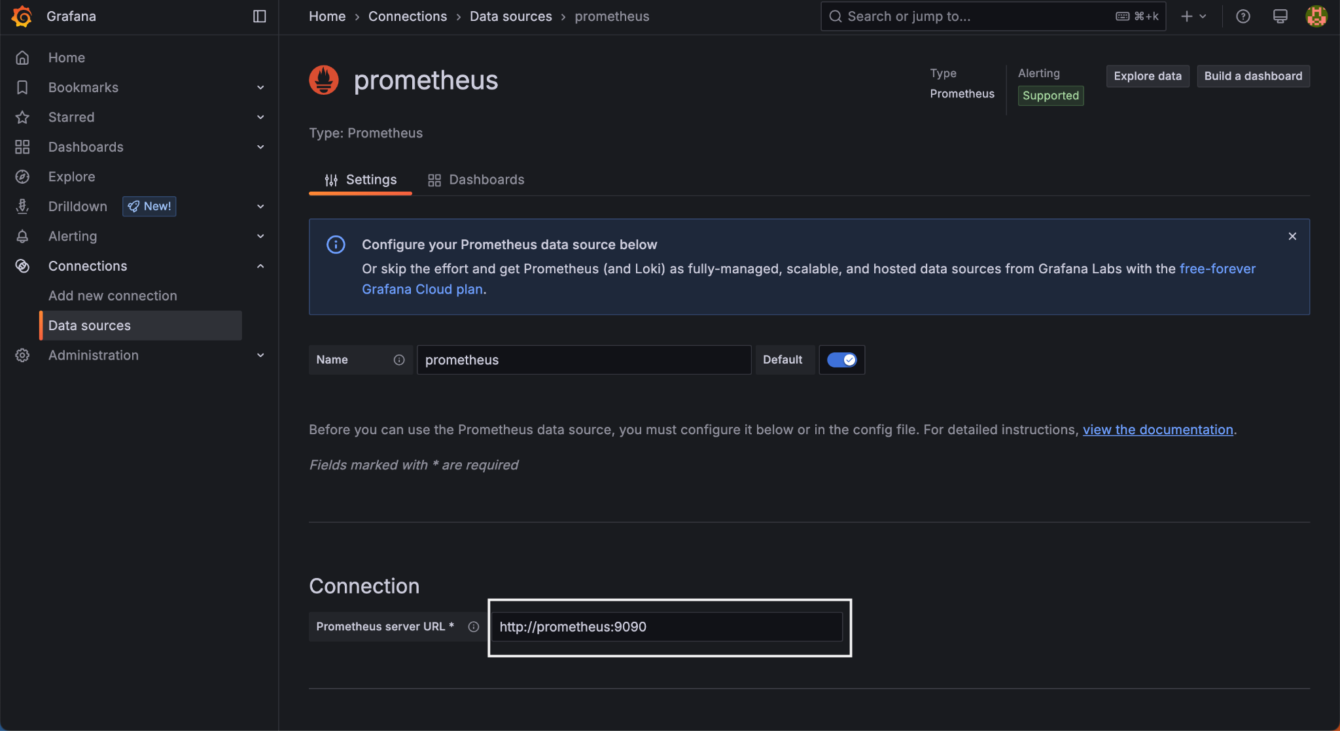
Next, navigate to the bottom and click on Save & test
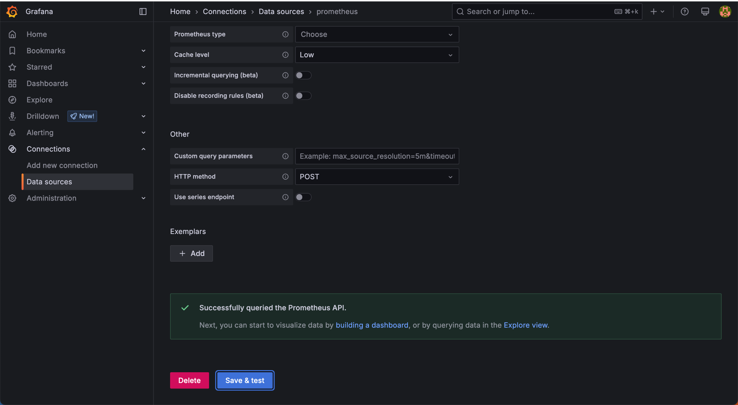

Verify metrics are reaching both Prometheus and Grafana
- On Prometheus
Navigate to the prometheus homepage
http://<public_ip_address>:9090
Enter the following query in the query parameter and click Execute.
process_cpu_seconds_total
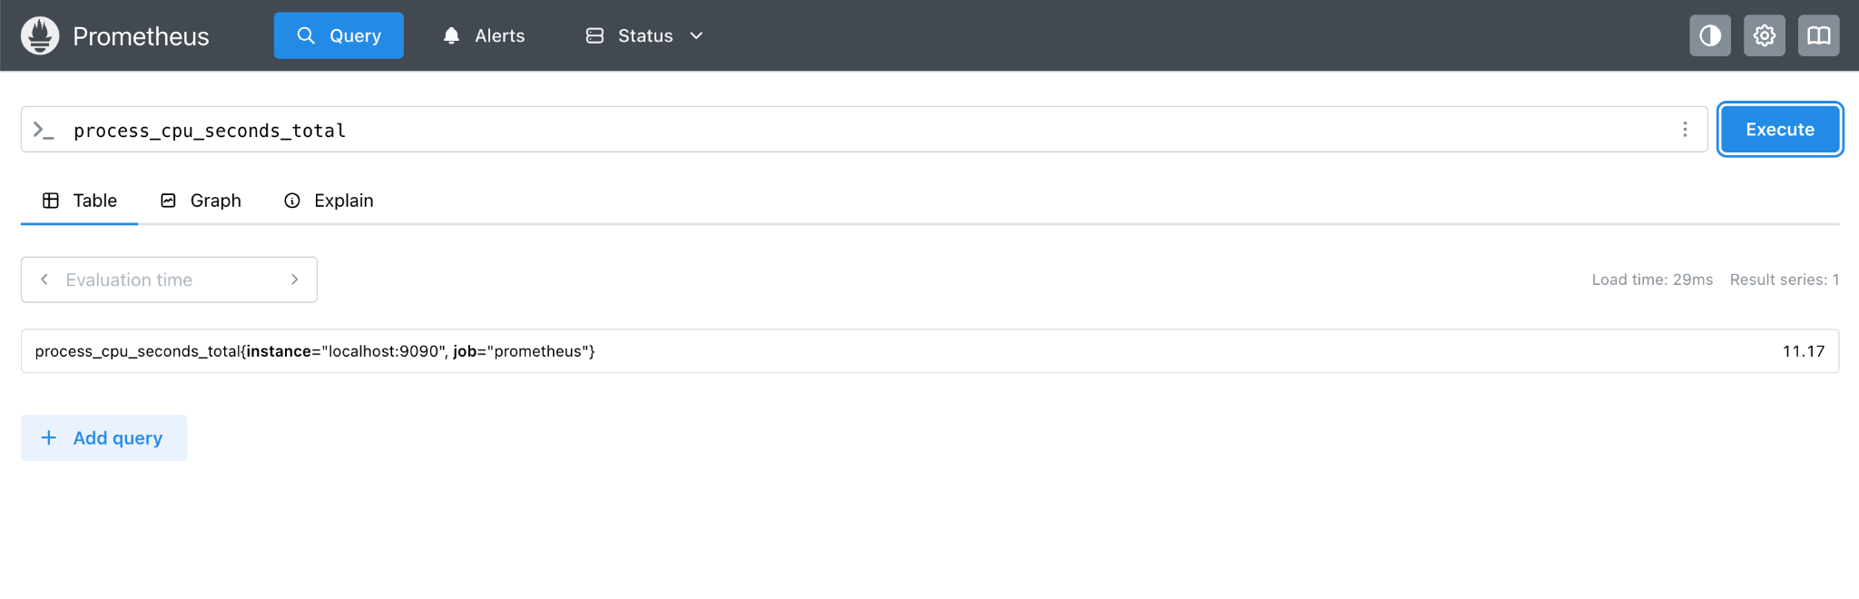
You will notice the data coming up. It is collecting the data from the localhost as defined in the prometheus.yml file.
- On Grafana
Navigate to the grafana homepage and login.
Navigate to the Explore >> In the query, select the metrics as “process_cpu_seconds_total”, add the label as “instance = localhost:9090” and run the query from the run button on the top corner highlighted in the screenshot below.

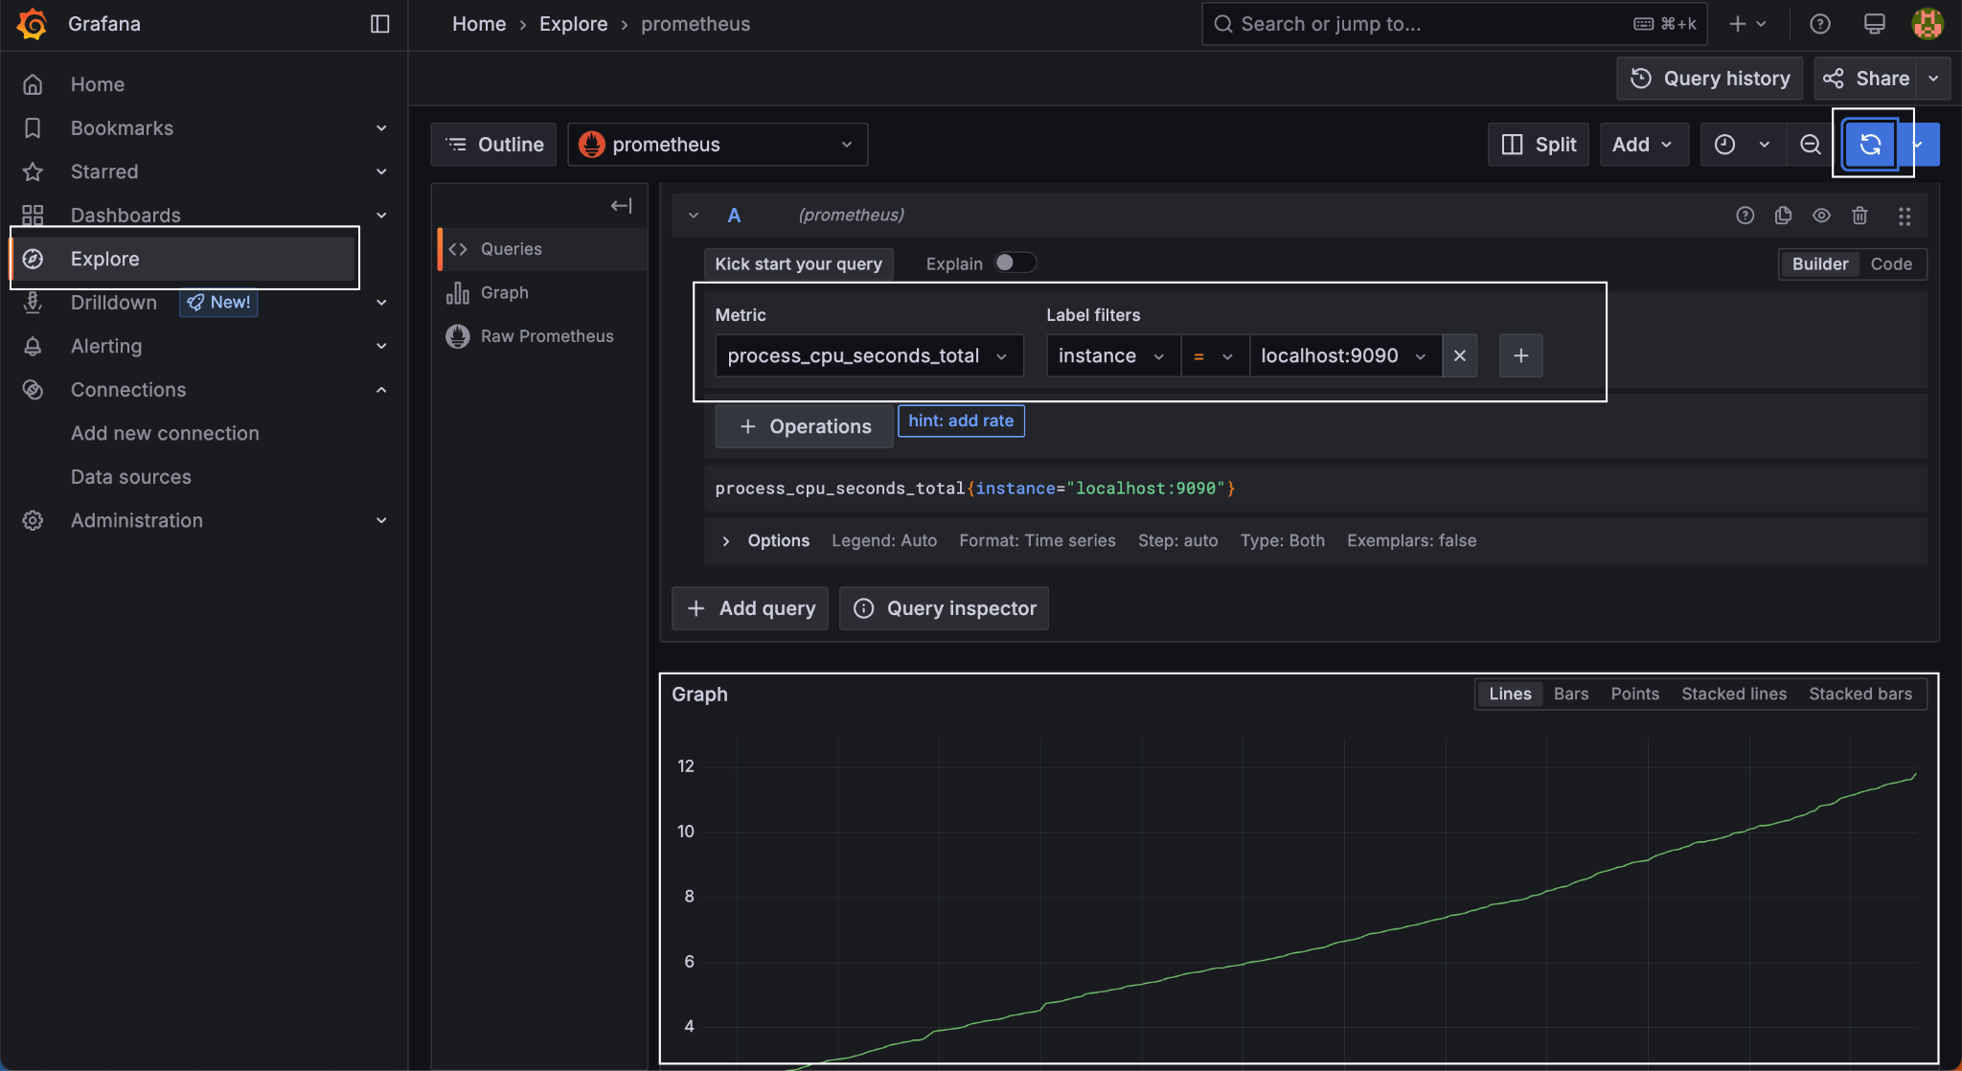
Once you execute the query, you will see a graph above. It shows that the data is collected from the localhost and is transferred to the Grafana via Prometheus.
Congratulations! We have completed this first lab where we set up Prometheus and Grafana and enabled the communication between the two services.

